
Singareni Collieries Women’s Degree and PG College, Kothagudem Report on Rangers and Ranger Team Leaders (RTLs) Activities
Ranger: A girl whether previously a Guide or not and who is a citizen of India and who has completed 15 years of age may be enlisted as a Ranger Aspirant, a person who has completed 25 years of age is not eligible to be a Ranger but she can continue as a Service Ranger up to the age of 35 years.

Wherever it is necessary, extension be allowed for 3 years with the special permission of the State Chief Commissioner. She will be eligible for Rashtrapati Ranger Award provided the special permission is granted before completion of 25 years of age and the same shall be reported to the National Headquarters.
Ranger Team: (i) A Ranger Team shall consist of not less than six and not more than twenty four Rangers.
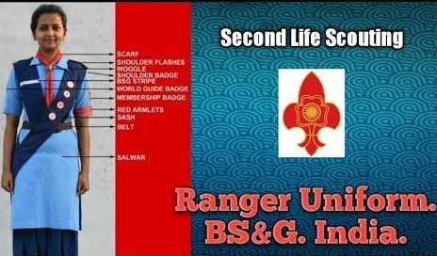
- A Ranger Team shall be a unit or group of Bulbul Flock, Guide Company and Ranger Team provided however, where there is no such group the Ranger Team shall be treated as a Group.
- Every Ranger Team shall be registered in accordance with the procedure laid down on this behalf.
- Every Ranger Team shall have a name, where the Ranger Team is a
unit of Group; it shall bear the name of the Group. The Group may be named after the locality or the institution or any great Personalities (Female) of India. Every Group shall have a serial number assigned by the Local or the District Association as the case may be.
The Ranger Leader and the Assistant Ranger Leader: (i) There shall be Ranger Leader for each Ranger Team. There may be one or more Assistant Leaders for a Ranger Team at the rate of one Assistant Ranger Leader for each six Rangers.
- The Ranger Leader and Assistant Ranger Leader shall be appointed by the State Chief Commissioner in consultation with the concerned State Commissioner on the recommendation of the Local or the District Association, as the case may be, and the concerned District Commissioner. On appointment the Ranger Leader and the Assistant Ranger Leader shall be issued each with a Warrant.
- The Ranger Leader and the Assistant Ranger Leader shall function subject to the general supervision of the Group Leader where there is a Group; the Ranger Leader shall be in general in charge of the affairs of the Ranger Team. She will, however, delegate matters of discipline, administration and finance of the Ranger Team to the Team Council. The Assistant Ranger Leader shall assist the Ranger Leader.

Qualification for the Ranger Leader and the Assistant Ranger Leader: (i) A person who has completed twenty one years of age is eligible for appointment as Ranger Leader. (ii) She should preferably possess the Degree in any discipline or equivalent qualification. However in exceptional cases, the condition of qualification can be relaxed by the State Chief Commissioner up to Matriculation.

Details of RTLs, SCWDC

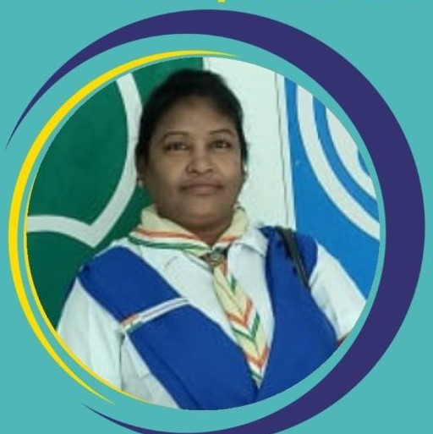

  - Smt.K.Asha Jyothi Advanced RTL.

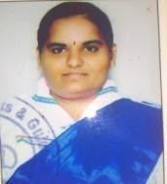
  - Dr.K.Rajyalaxmi Advanced RTL. Telangana State Project coordinator from December-2020 to March-2021

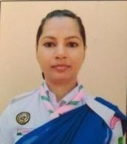
  - Smt.Shaheda parveen Advanced RTL.

Dr. Ch. Sarada, Principal, SCWDC.
District Commissioner (G), Bharat Scouts and Guides,

Singareni District Association.

  - Smt.V.Rajani Advanced RTL.


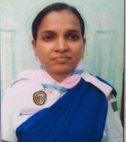
  - Smt.P.Vishalini Advanced RTL.

  - Smt.K.Swaroopa Rani Advanced RTL.
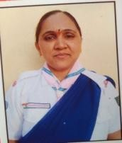
  - Smt.G.Vijaya Advanced RTL.

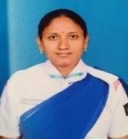
  - Smt.V.Renuka Advanced RTL.

    - 5th State Council meeting: Smt. Ch. Sarada District Commissioner (G), Singareni Collieries District Association attended the State Council meeting and participated in BSG Telangana State Elections at SHQ, Hyderabad.
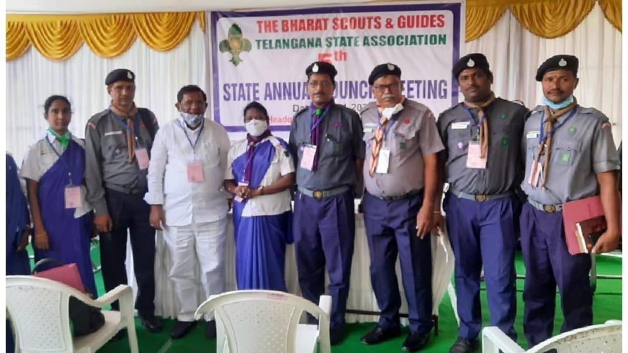

    - Advanced Course for Ranger Team Leaders - 27-01-2020 to 02-02-2020: SCWDC RTLs attended and successfully completed Advanced Course for Ranger Team Leaders held at BSG, District Head Quarters, Singareni from 27-01-2020 to 02-02-2020.
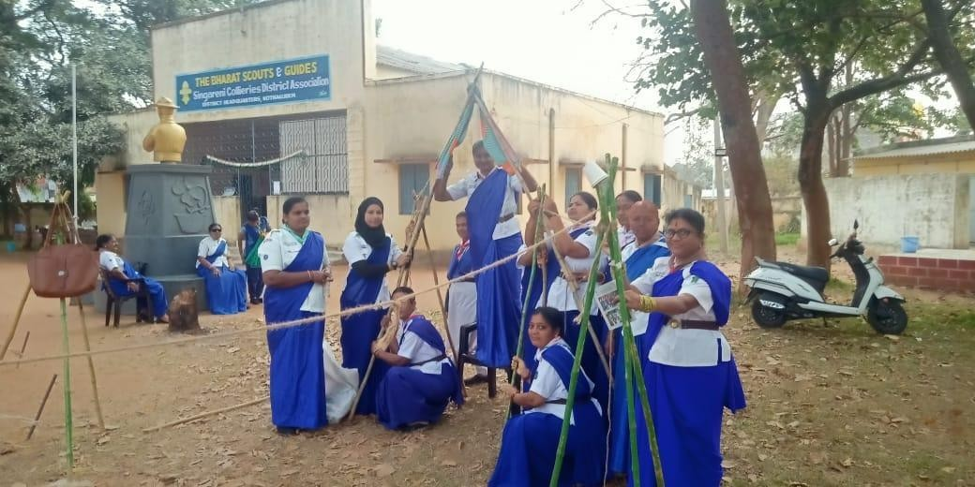

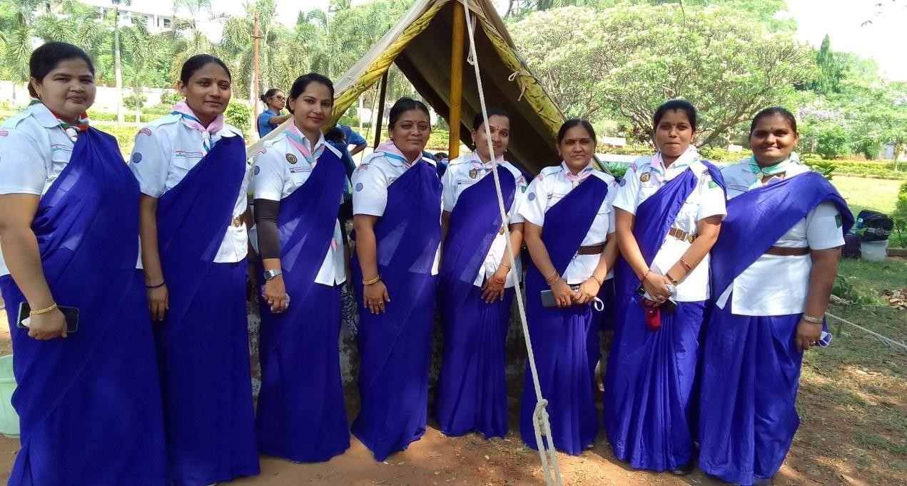

    - Dr. K. Rajyalaxmi appointed as a Telangana state project coordinator for Equity, Empowerment, Engagement Project,The Bharat Scouts and Guides, National Head Quartes, New Delhi in collaboration with WAGGGS (World Association of Girl Guides and Girl Scouts)
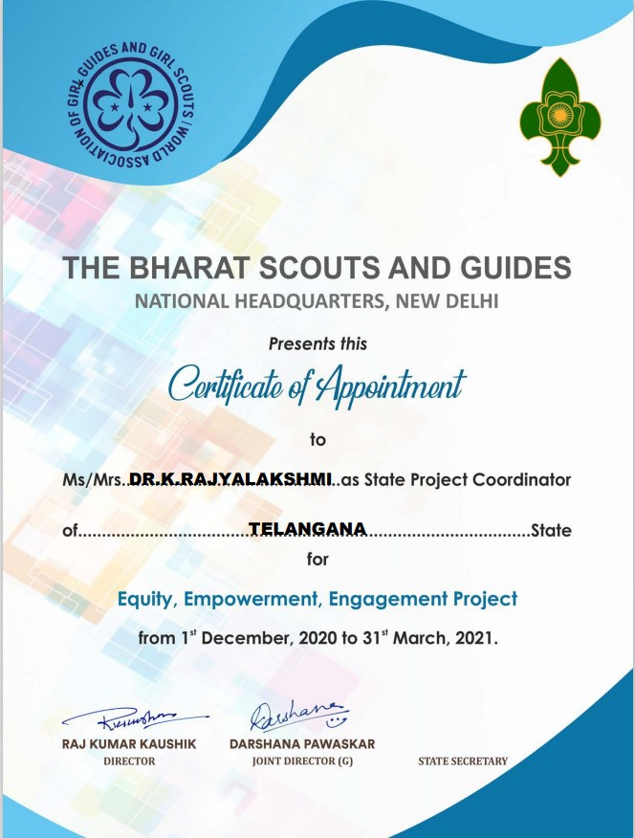

    - Pulse Polio vaccination service program – 31-01-2021: RTLs and Rangers actively participated in pulse polio vaccination.
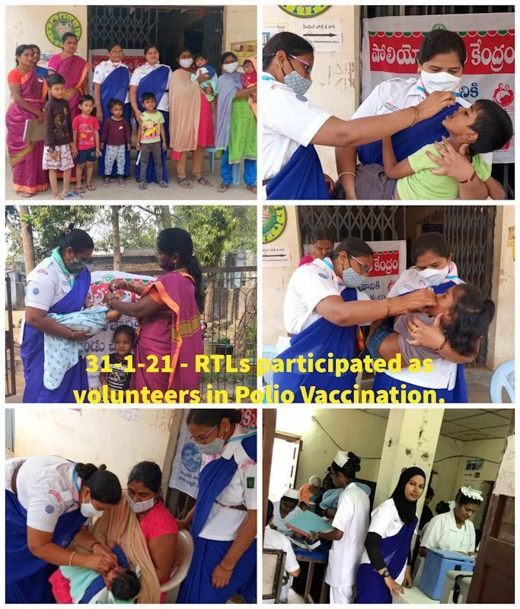

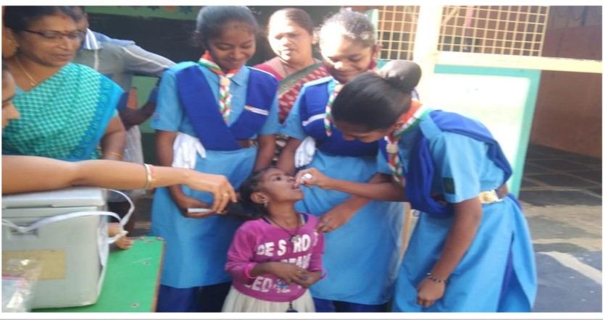

    - World Thinking Day 2021 – 22-02-2021: Rangers and RTLs participated in World Thinking Day 2021 rally with the theme of 'Stand Together For Peace' organized by BSG Singareni District Association at DHQ, SIngareni.
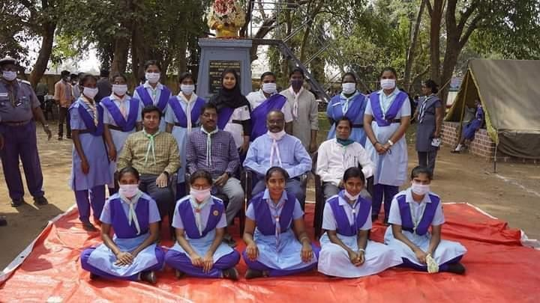
    - Medicinal plants exhibition at Ramavaram area - 09-03-2021: 15 rangers participated in Medicinal plants exhibition and distribution.
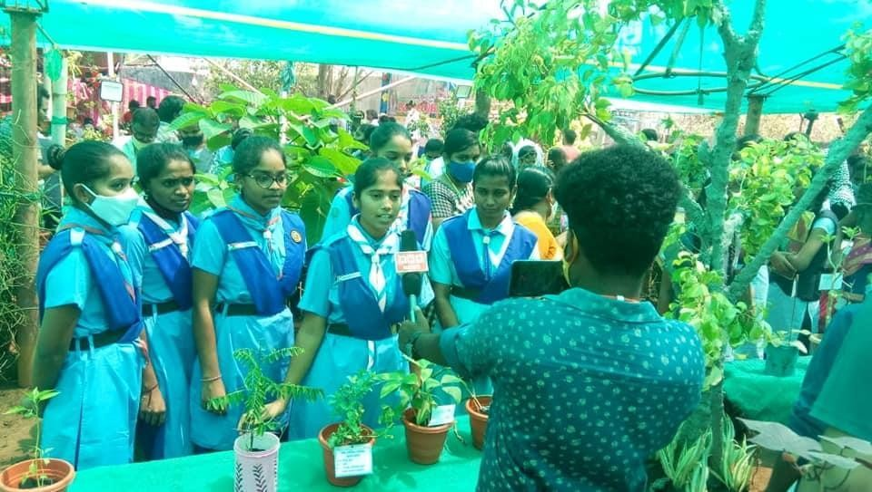

    - Leadership workshop -17-03-21 to 22-03-21: Dr. K. Rajyalaxmi, RTL participated as a State Project Coordinator, Telangana State in Leadership workshop on Prepared to learn Prepared to Lead held at National Head Quarters, New Delhi.
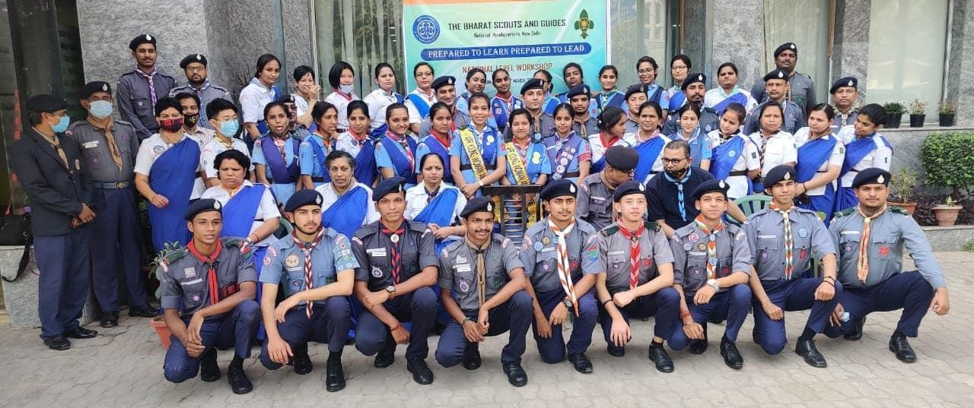
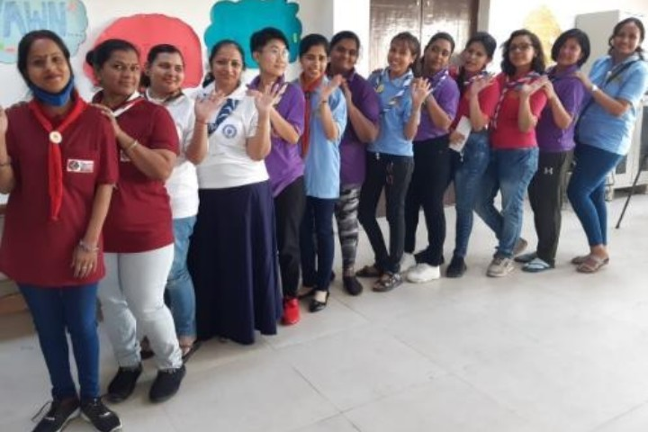
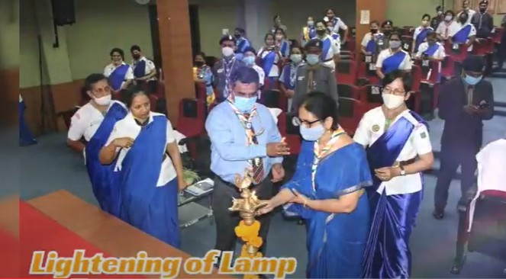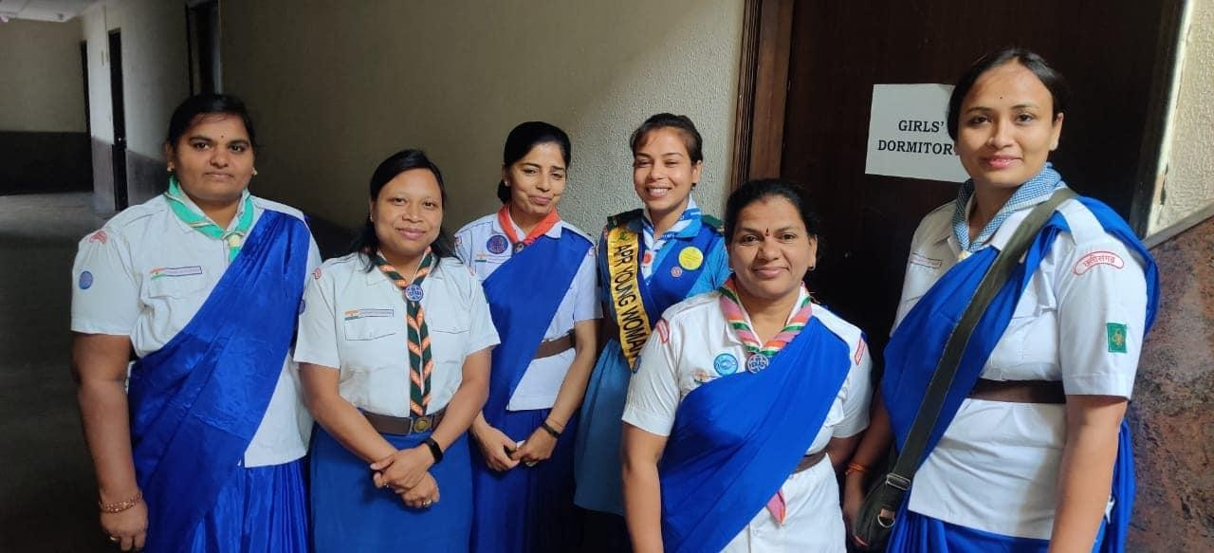


    - Star of the April Month 2021: Dr. K. Rajyalaxmi, RTL, SCWDC, Telangana State Project Coordinator was selected STAR OF THE APRIL MONTH for HE WORLD HER VOICE (UPS) Project.

    - Pandemic services from 09-06-2021 to 15-06-2021: SCWDC Rangers & RTLs in collaboration with BSG Singareni have rendered their services in various activities like food distribution, mask distribution at bus stations, railway stations during the Covid pandemic period.
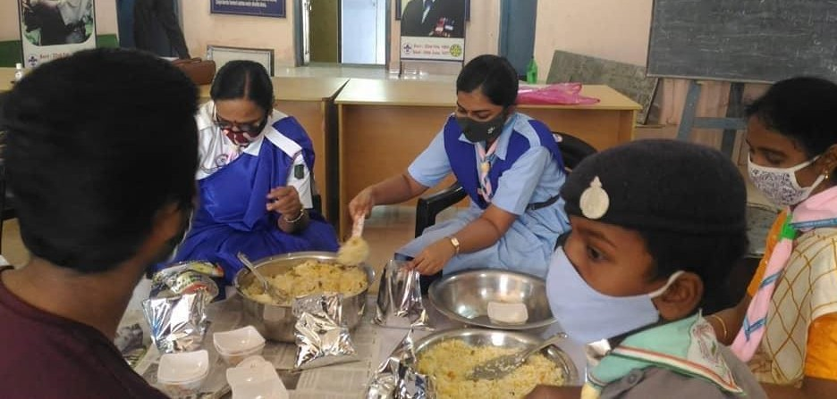

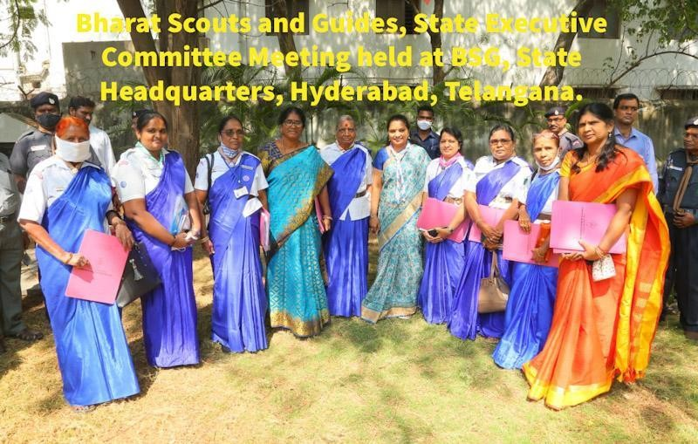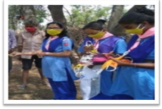
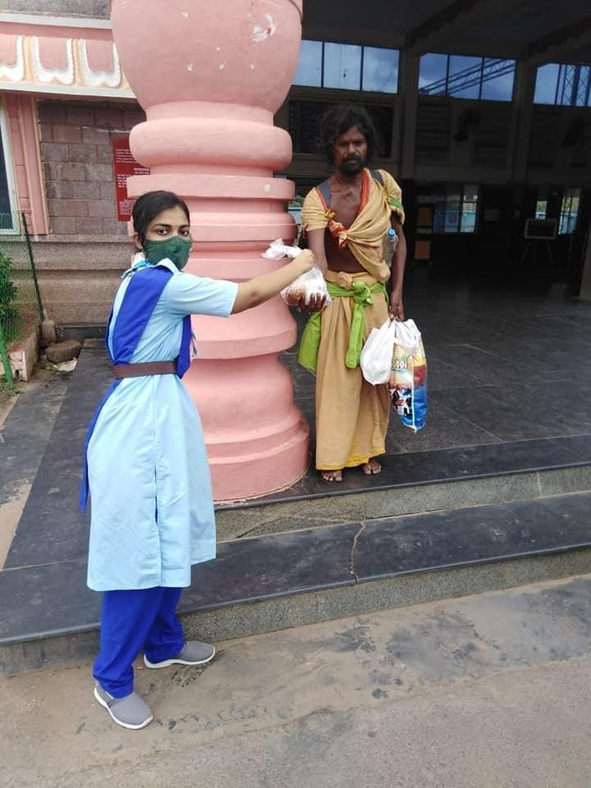

    - International Yoga Day-21-06-2021: On account of International Yoga Day SCWDC Principal, RTLs, Rangers performed various ‘Yoga Asanas’ at campus.
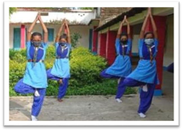
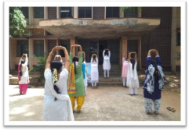
    - Administrative workshop from 28-06-2021 To 30-06-202: Dr. K. Rajyalaxmi, RTL Participated as Telangana State Project coordinator in an online webinar on Administrative workshop organized by BSG Telangana State Association through ZOOM meeting.

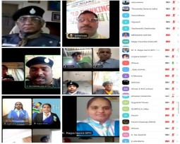

    - Singareni Day Celebrations -23-12-2021: On the occasion of Singareni Day - 2021,
Rangers received the Chief Guest Sri N. Balram Naik, IRS, SCCL with March past. After that rangers rendered their services in water and snacks distribution at Prakasham stadium.
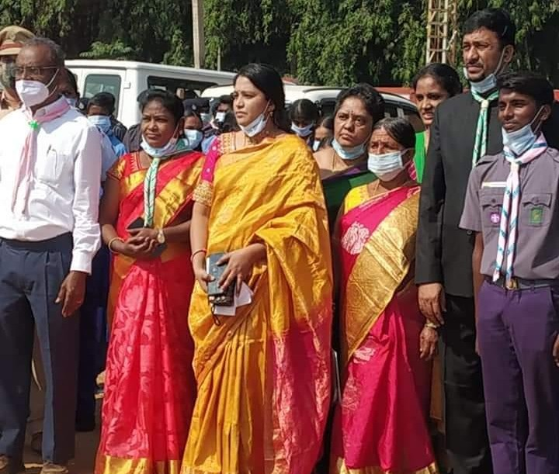
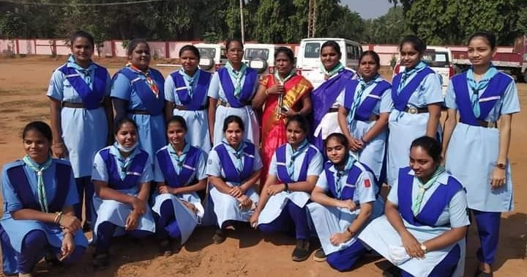

    - Vaccination Drive 07-01-2022: Rangers rendered their service in covaxin and covishield vaccination drive in SCWDC Campus organized by SCES in collaboration with Govt. Health care Department, Kothagudem.
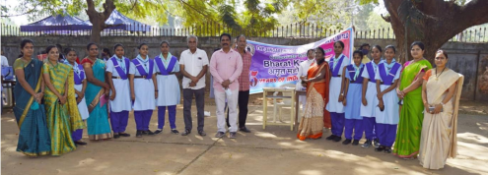

    - World Thinking Day 22-02-2022: Rangers participated in All India Radio program on World Thinking Day – 2022 with the theme of "Our World: Our Equal Future: The

Environment and Gender Equality.”
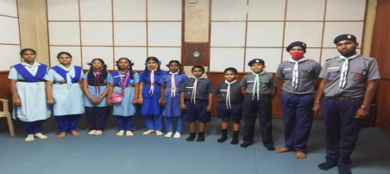

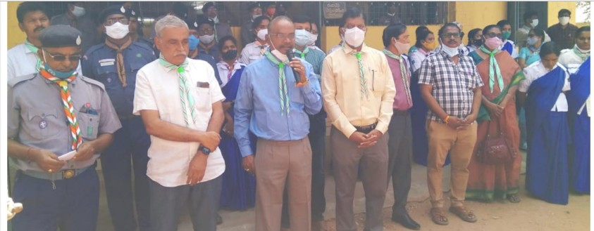
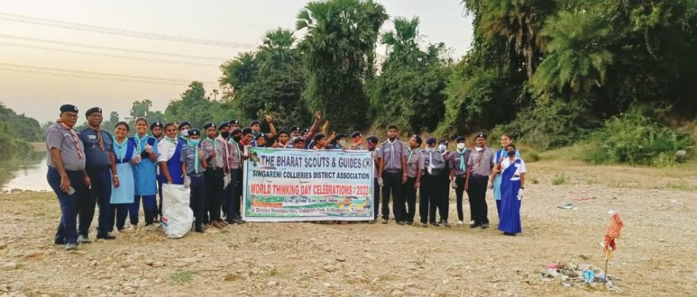
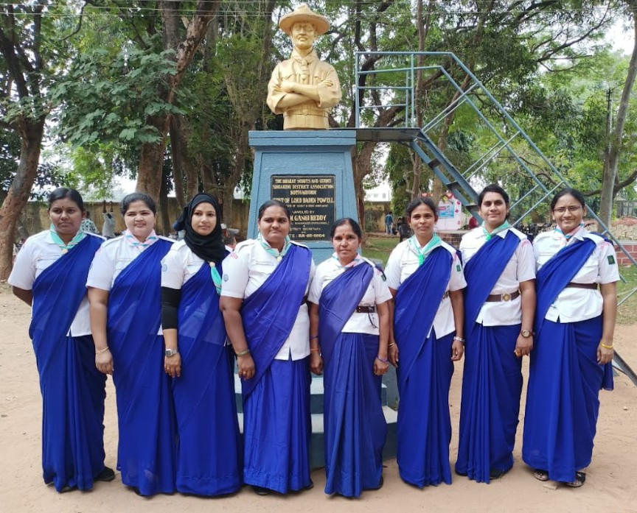

    - FREE BEING ME & ACTION ON BODY CONFIDENCE (ABC) – 24-02-2022: SCWDC RTLs in collaboration with BSG Singareni District Association and Telangana State Association organized a Workshop on Free Being me and Action on Body confidence at SCWDC auditorium.
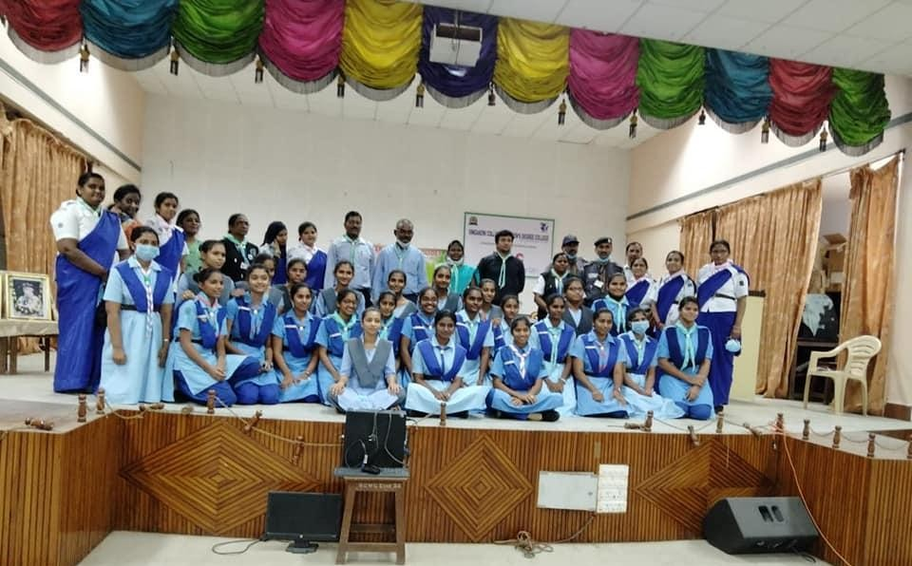
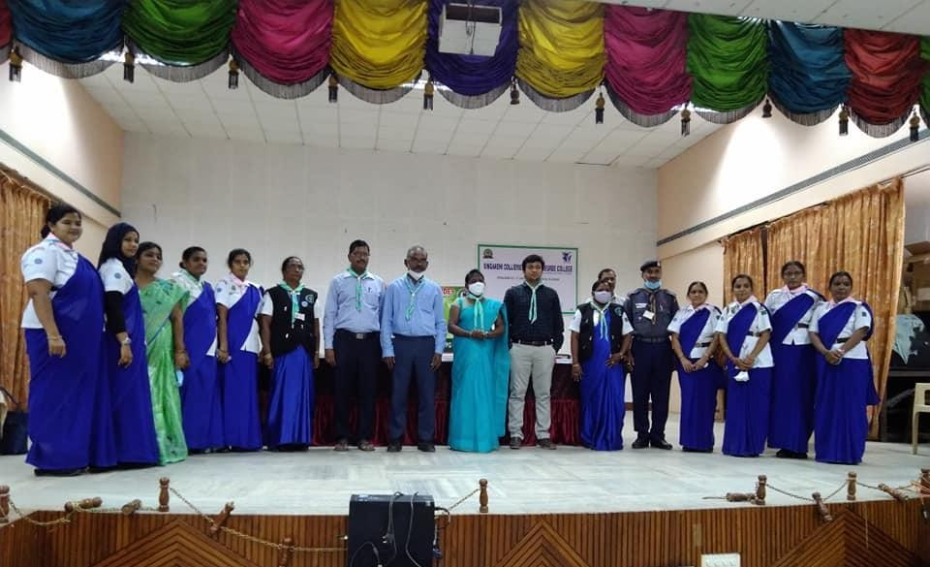

    - BSG TS with our Governor Dr. Thamilisai Soundara Rajan -13-04-2022: SCWDC Principal, RTLs and Rangers met our Hon'ble Governor Dr. Tamilisai Soundara Rajan at the Bungalows, Kothagudem.
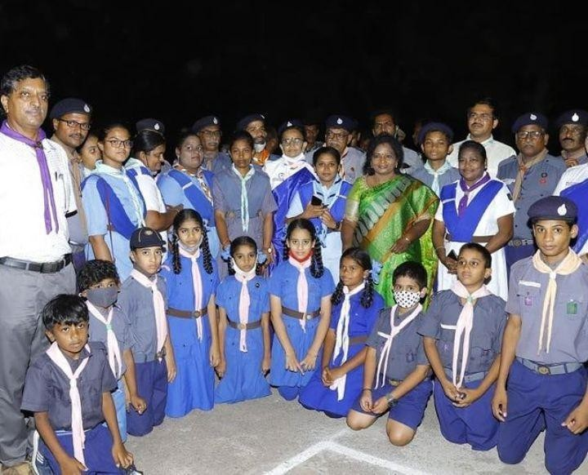
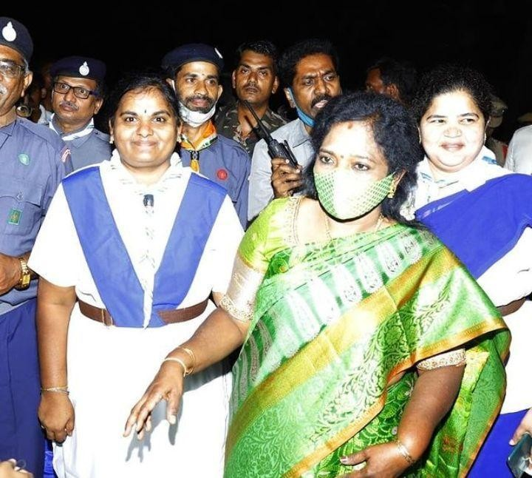

    - Rock climbing - 22-04-2022: Rangers successfully completed 50 feet rock climbing at Karukonda Ramavaram as part of Nipun Syllabus.
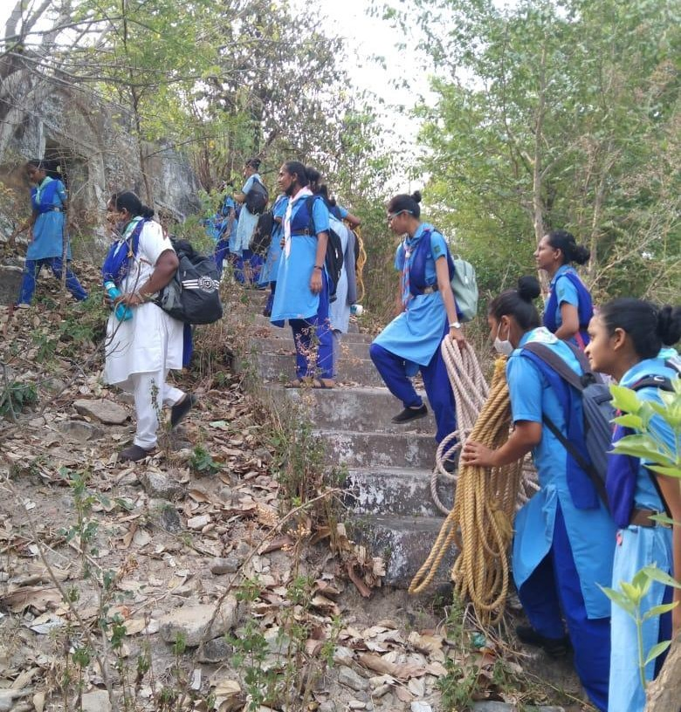
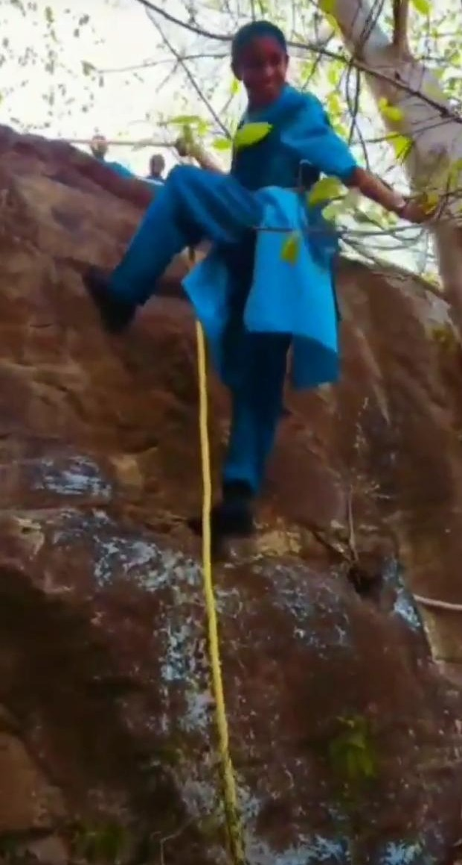

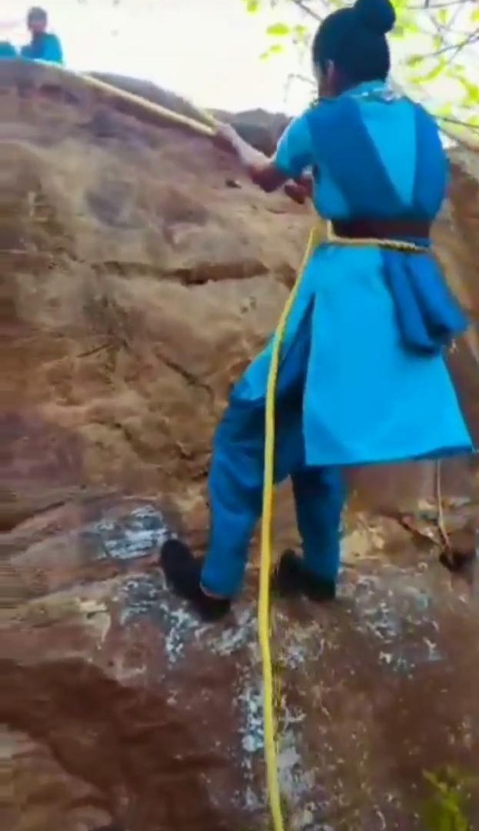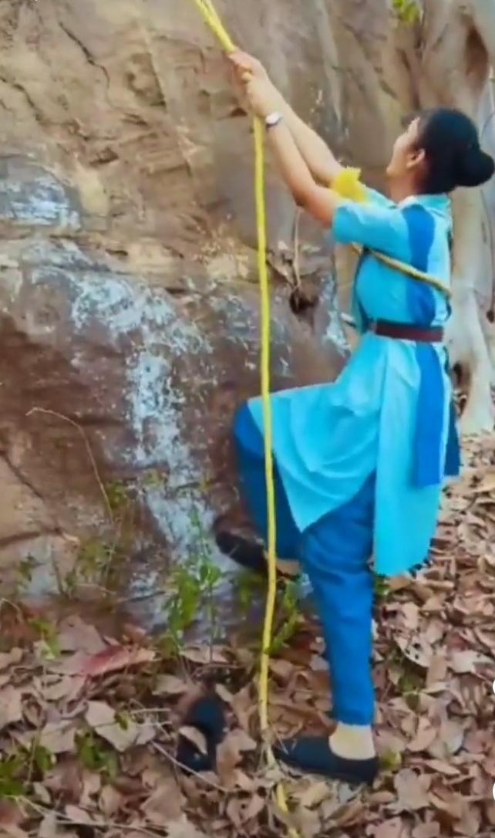

    - NIPUN Testing Camp for Rangers- 26-04-2022 to 30-04-2022: 30 Rangers appeared for NIPUN testing camp at District Headquarters, Singareni Collieries District from 26-04-2022 to 30-04-2022.
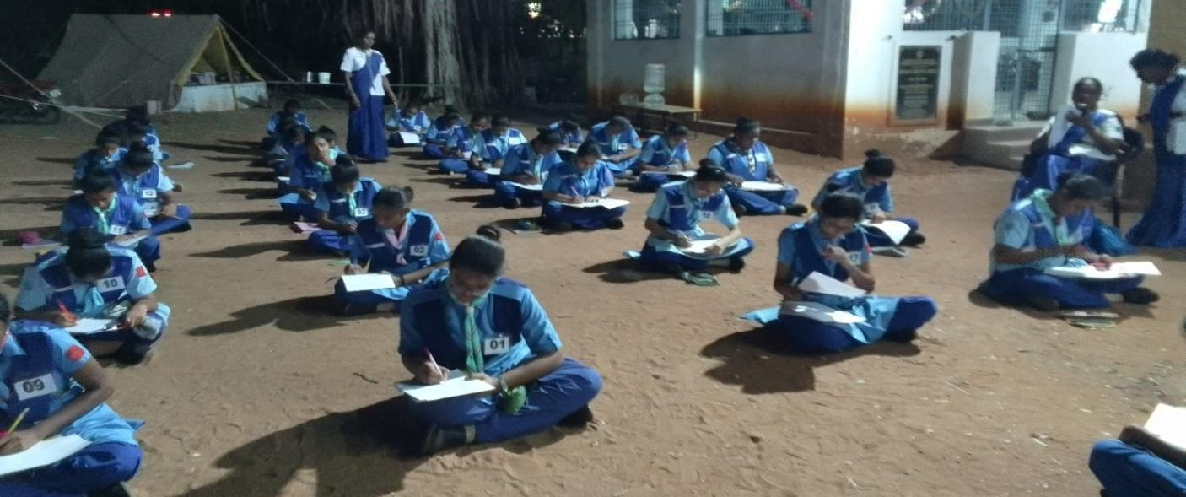

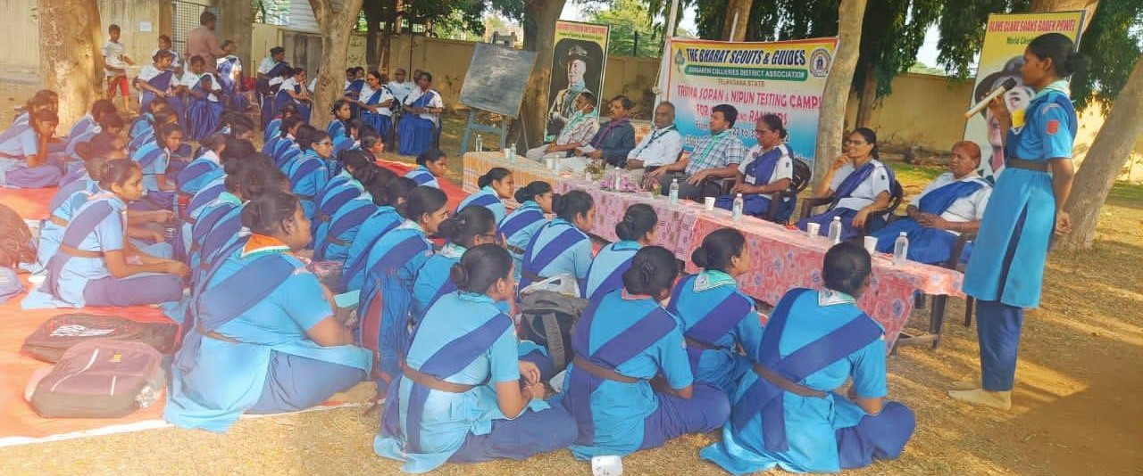
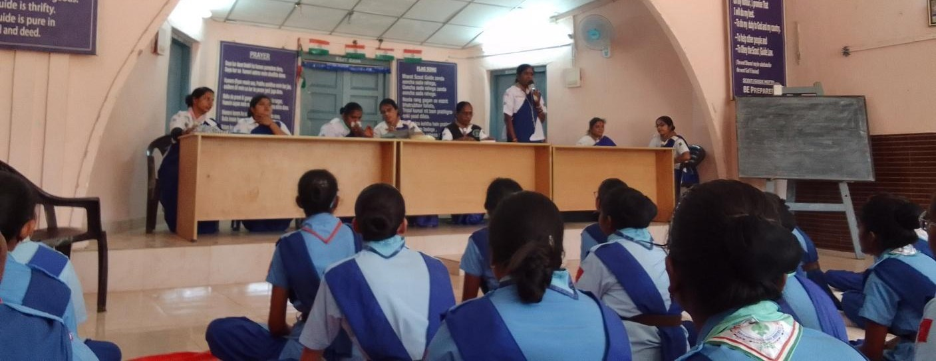

    - Singareni District Rally-08-12-2022 to 10-12-2022: SCWDC RTLs and Rangers participated in Singareni District Rally-2022 at BSG Singareni District Head Quarters,
Kothagudem.
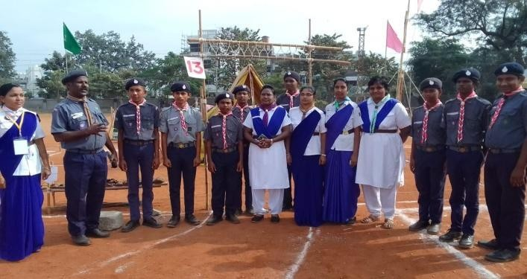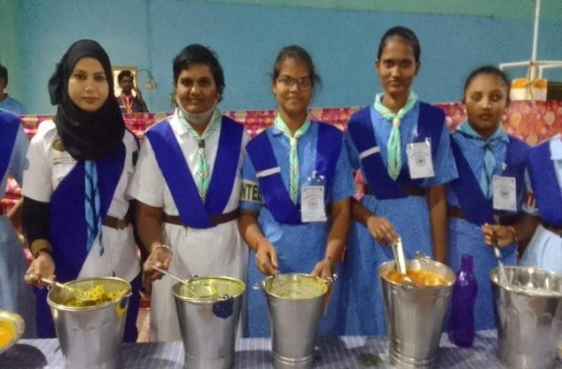

    - Singareni Day Celebration-23-12-2022: Rangers rendered their services on the occasion of Singareni Day Celebrations – 2022 at Prakasham stadium.
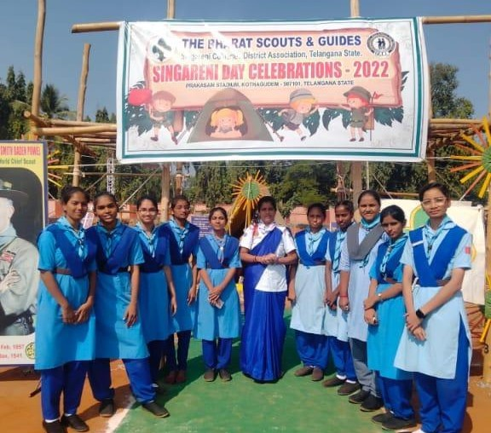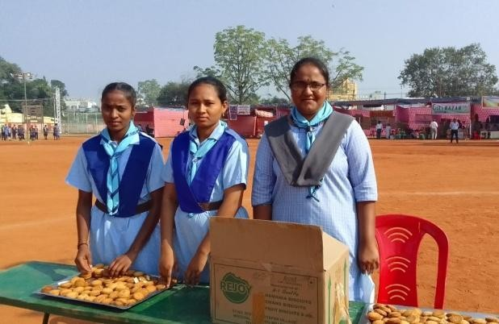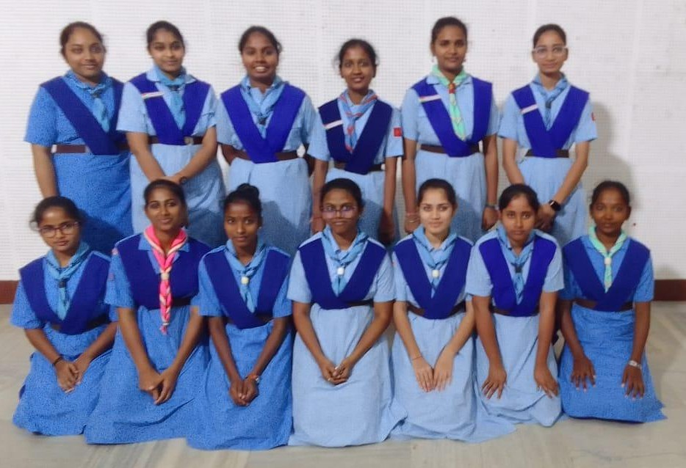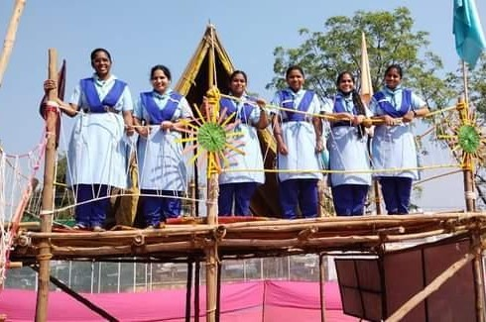

    - A Two Day Workshop on MIST- 17-03-2023: Over 20 Rangers rendered their service at A Two Day Workshop on MIST – Motivation, Innovation, Support, Training organized by Dept. of Commerce, SCWDC, Kothagudem by lending a helping hand to students, supplying water and managing the crowd with discipline manner.
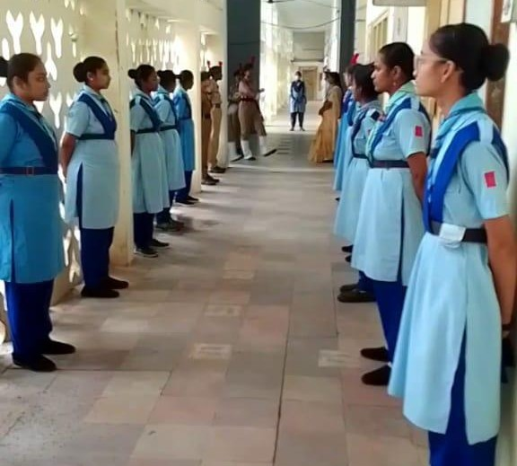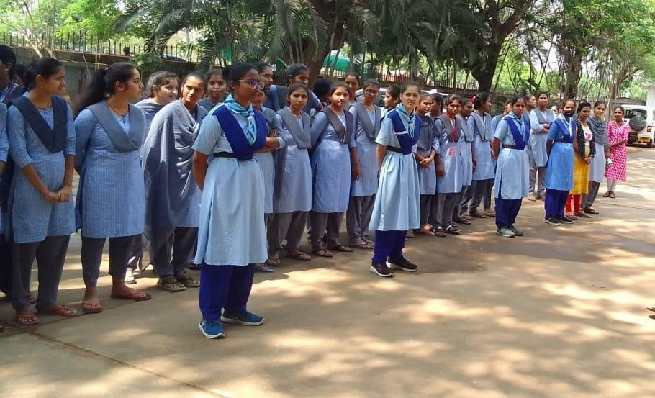

    - 77th Independence Day – 15-08-2023: On the occasion of the 77th Independence Day, 40 Rangers participated in the March parade and rendered their services at the Prakasham Stadium, Kothagudem.
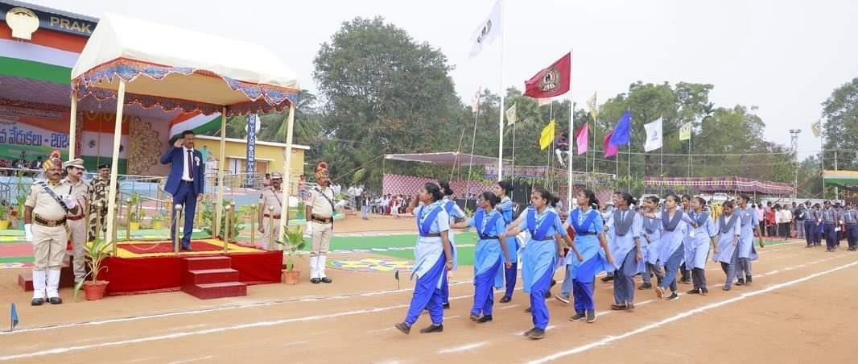

    - PIONEERING & CAMP CRAFT TRAINING CAMP – 05-02-2024 to 07-02-2024: Rangers Participated in PIONEERING & CAMP CRAFT TRAINING CAMP for Scouts and Guides at Bhupalapalli area, Singareni District.
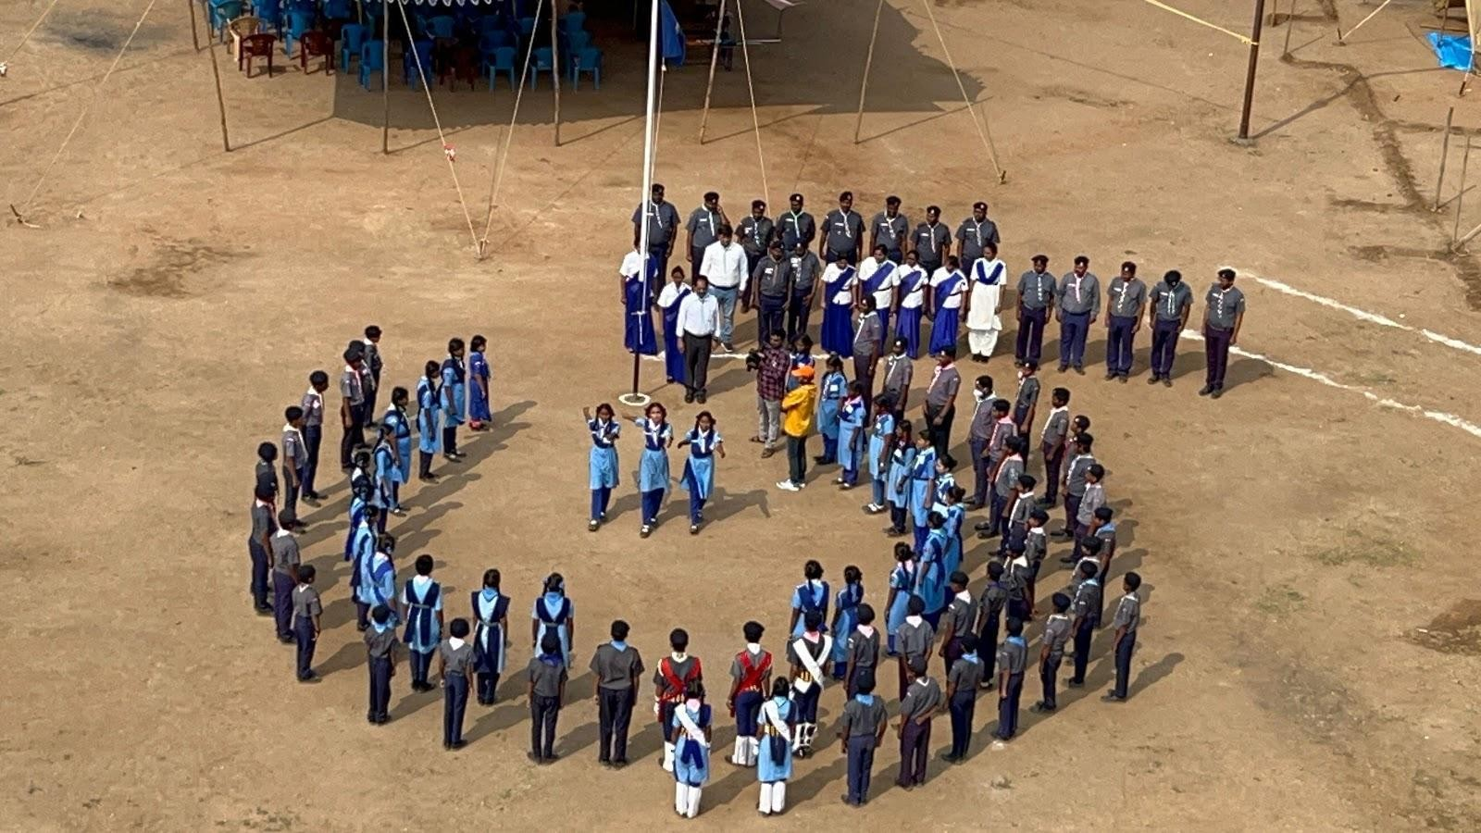
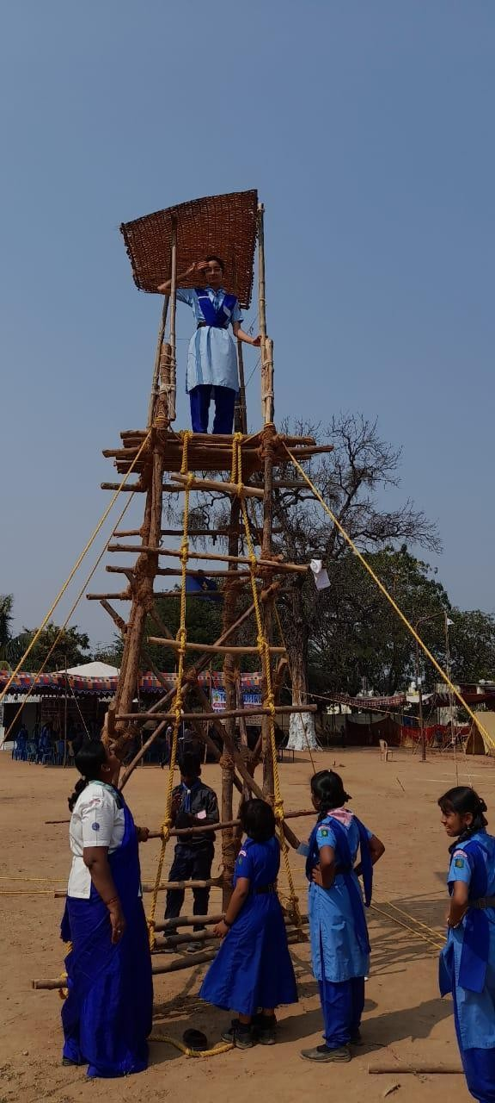

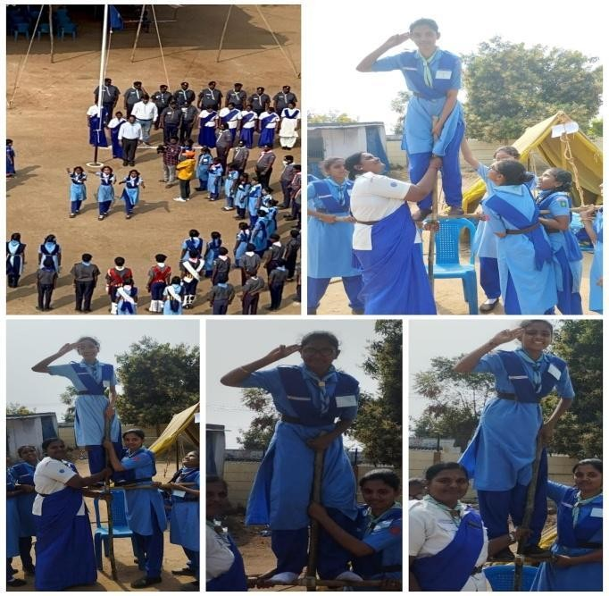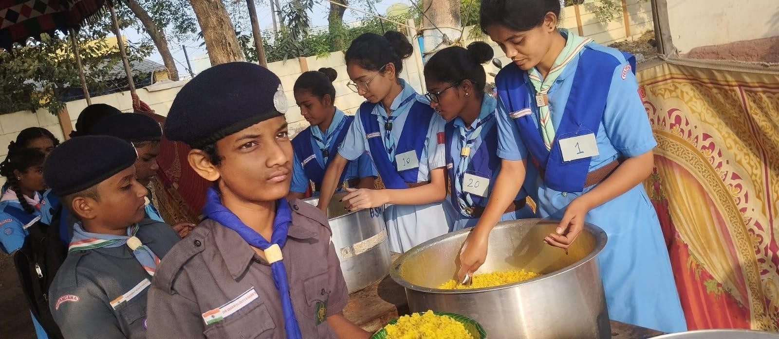
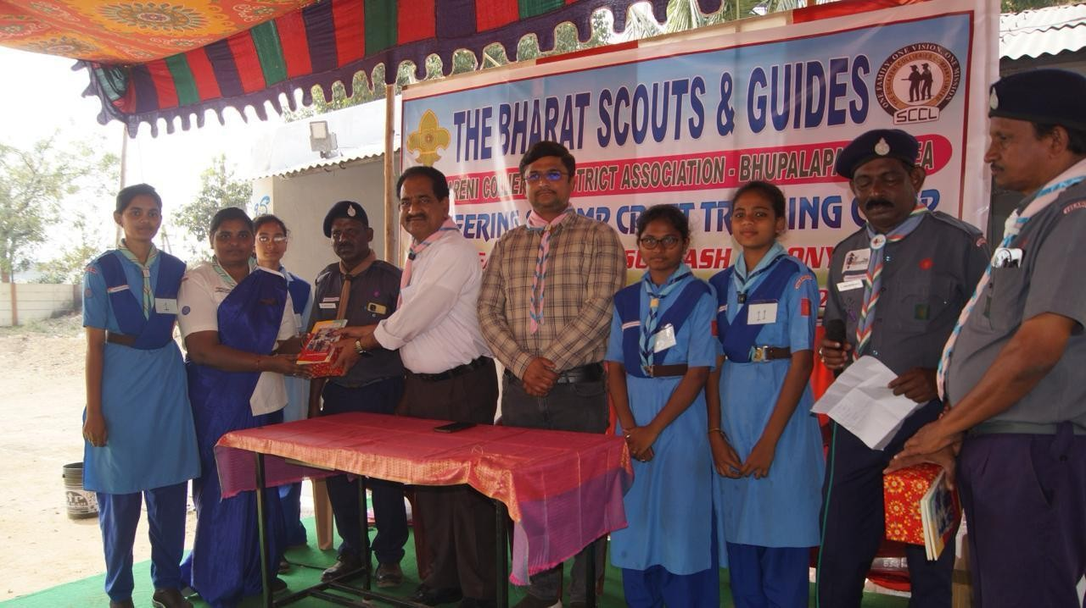
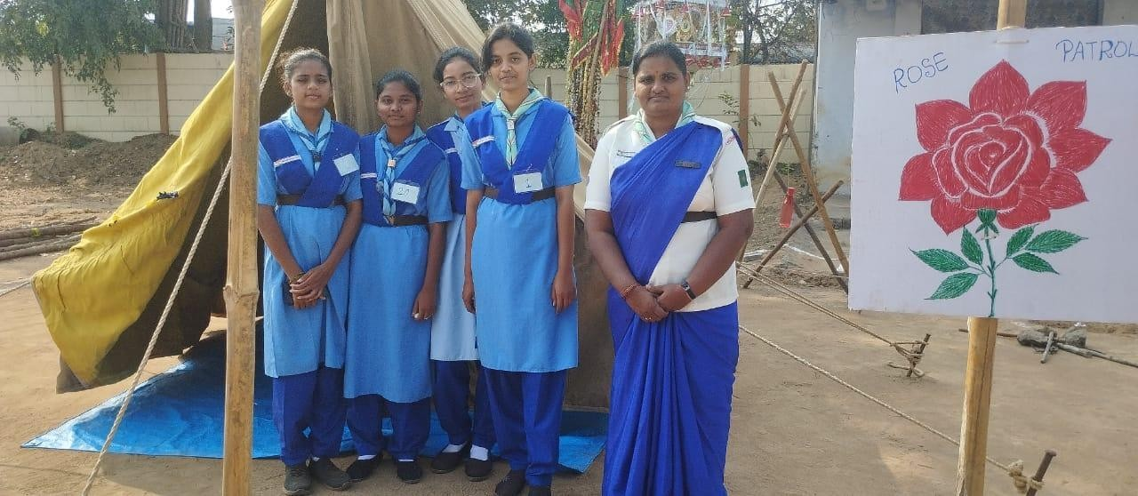

    - WORLD THINKING DAY – 22-02-2024: RTLs and 10 Rangers Participated in WORLD THINKING DAY – 2024, Theme: 'Our World, Our Thriving Future,' which emphasizes the importance of creating a sustainable and inclusive world where girls have the opportunity to thrive.
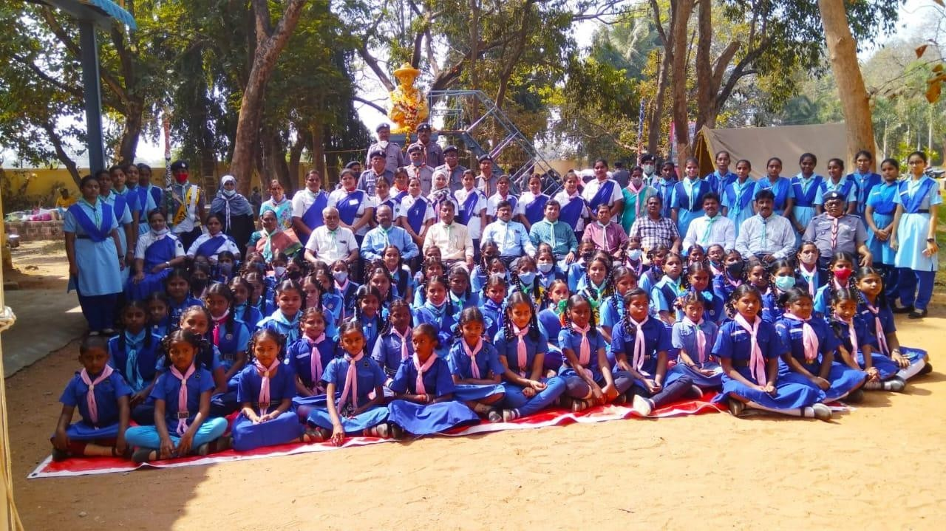
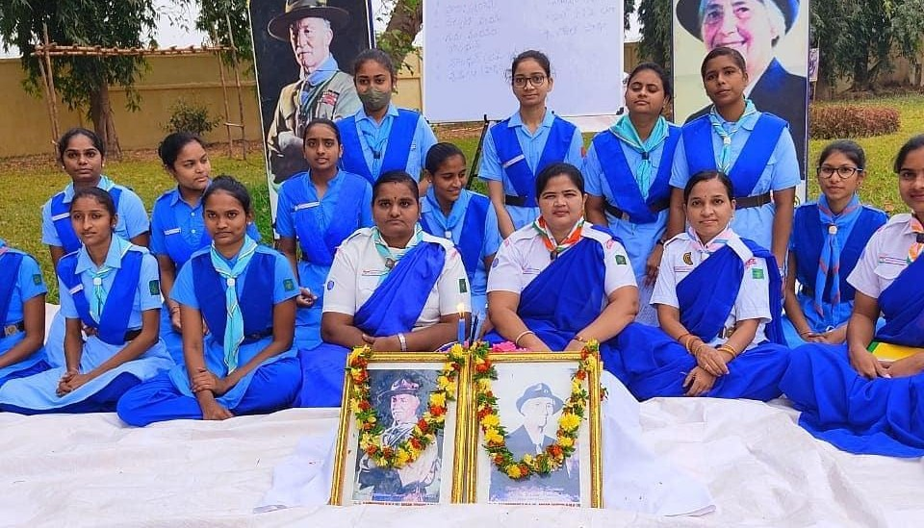

    - WORLD WATER CONSERVATION DAY – 22-03-2024: On account of the “World Water Day - 2024’ Theme: 'Water for Peace', Rangers cleaned two lakes in Kothagudem.

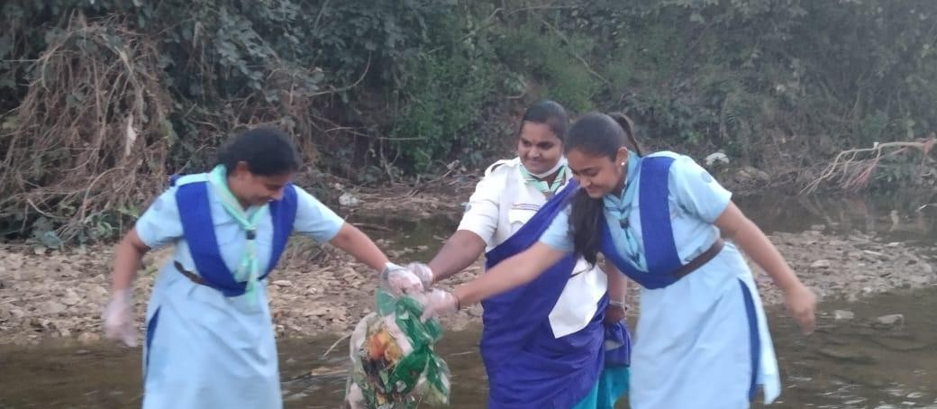

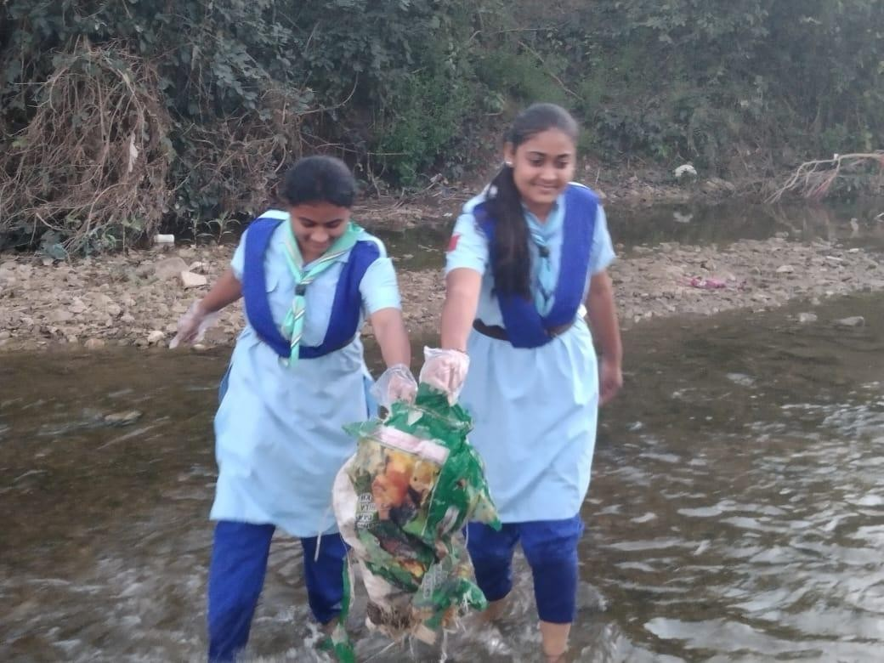

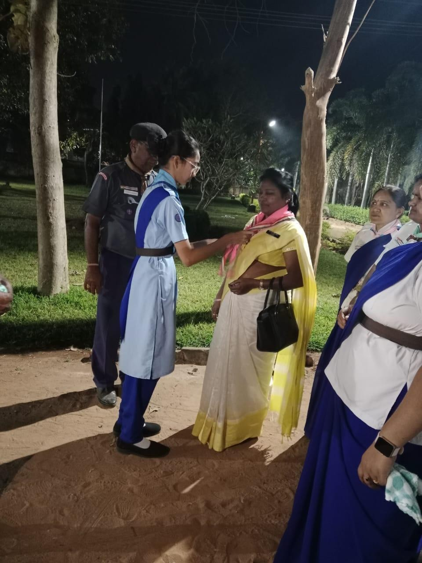
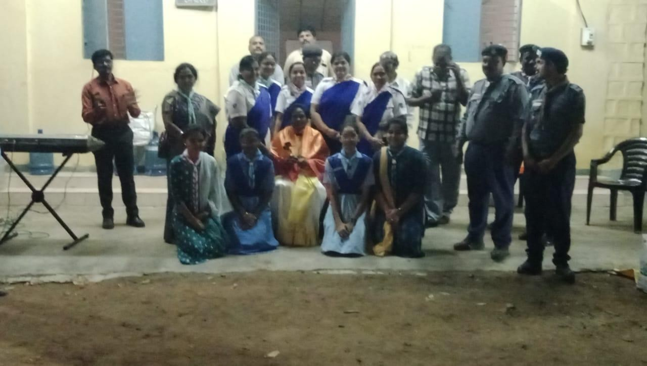
    - Felicitation to Doctorate: Bharat Scouts and Guides Singareni District Association facilitated Dr. Ch. Sarada, District Commissioner (G) for the awarded Ph.D from Osmania University.

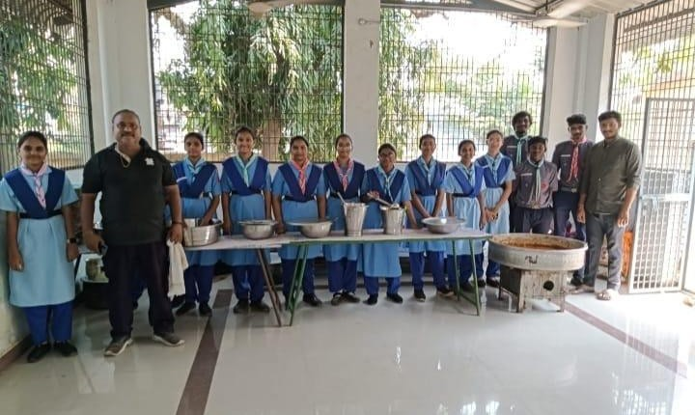
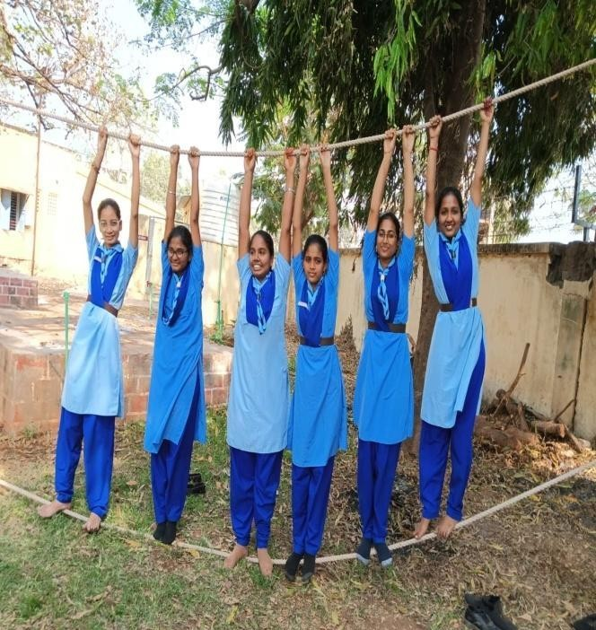
    - Community Singing Course – 12-03-2024 to 16-03-2024: 1 RTL & 4 Rangers Attended and successfully completed Community Singing Course for Scouts & Guide and Rangers & Rovers.

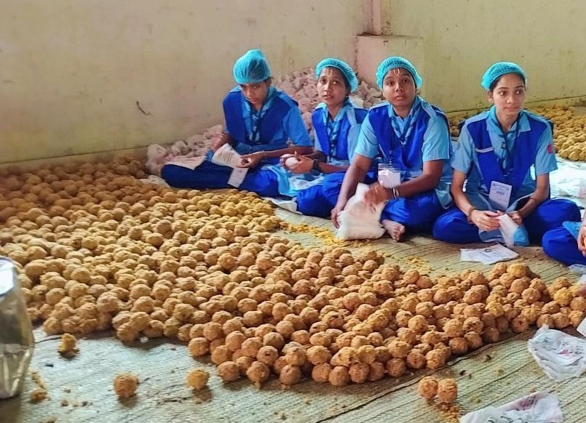
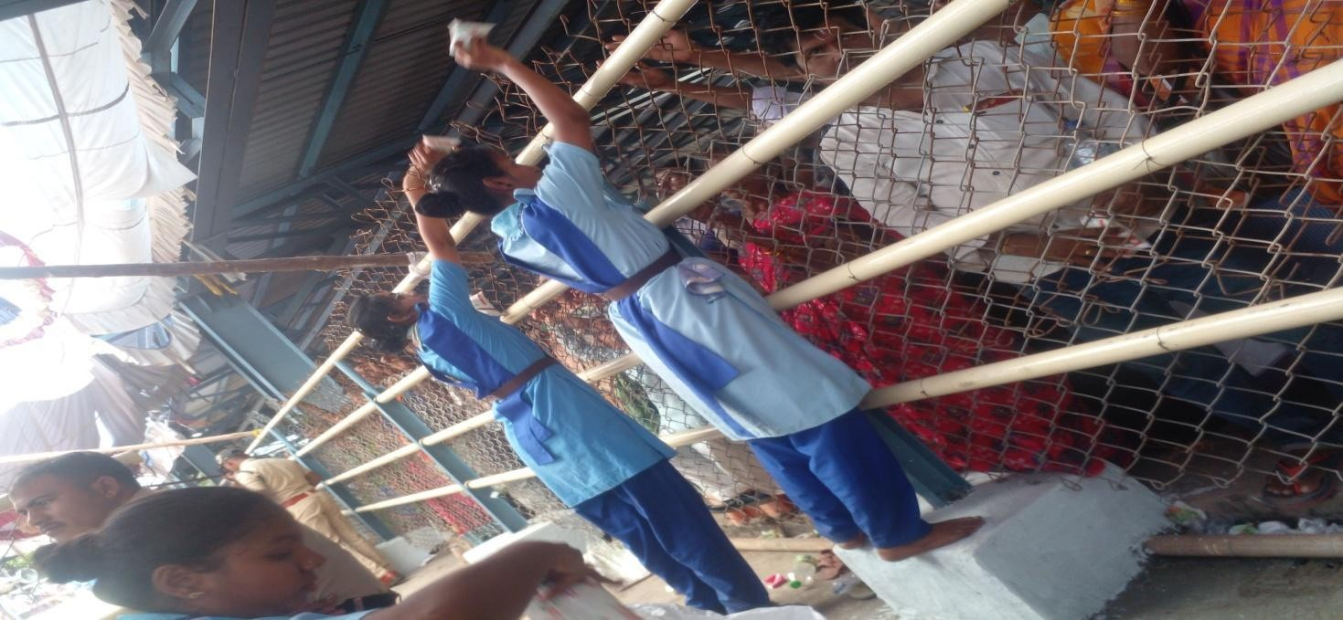
    - SCWDC Rangers in collaboration with BSG, Singareni District Association voluntarily participated in various service activities.

